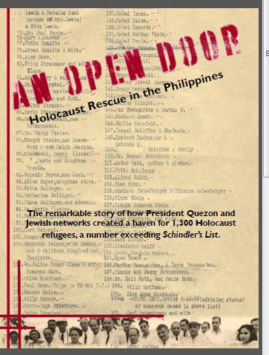

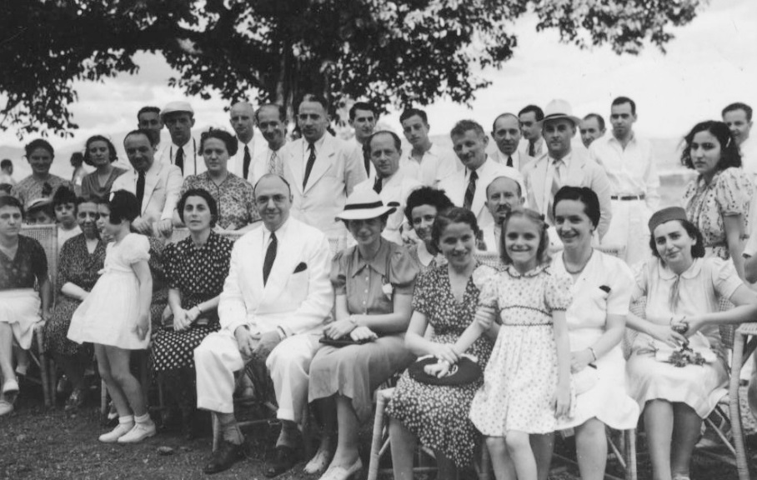

Holocaust Rescue in the Philippines

In 1937, an increasing number of European Jews made the painful decision that they must leave their homelands or be destroyed by the Nazi juggernaut. As Hilter's control spread over Europe, the Nazi regime systematically stripped Jews of their rights and, not coincidentally, their economic assets, consequently rending Jews "undesirable" for economic reasons if for no other. As more and more Jews decided to flee their homes, fewer and fewer countries were willing to let them in. The Philippines was one of the few that offered an open door. The cohort of European Jews who found not just shelter, but a home in the Philippines became known as Manilaners. In addition to accepting Jewish refugees into the country, the Philippines, and Filipinos, offered religious and ethnic tolerance. This is a story of beneficiaries becoming benefactors; as the Japanese interned civilians strictly by nationality during its Occupation of the Philippines (1942-1945), German and Austrian Manilaners were not interned, and many helped Filipinos and internees, even risking their own lives by joining the underground. Some Manilaners joined the USAFFE, and shared the fate of the Filipino and American soldiers of Bataan and Corregidor. Although many of the Manilaners left the Philippines after the end of the war, they had formed life-long bonds with Filipinos and the Philippines, carrying fond memories and friendships with them across the globe in the post-war diaspora. In the Manilaners, we see an unusual Holocaust story: one of kindness, acceptance, and hospitality given and returned across national, religious, racial, and ethnic lines, and one that leaves in its wake not devastation and death, but friendship and lives saved.

Bio: Sharon Delmendo is Professor of English at St. John Fisher College, where she teaches 19th century American Lit, Multicultural Lit, and Film Studies. She did much of the research for her first book, The Star-Entangled Banner: One Hundred Years of America in the Philippines (Rutgers University Press 2004, University of the Philippines Press 2005) in 1995-96 as the Fulbright Professor of American Studies at De La Salle University in Manila.
She is writing a history of the Manilaners, In Time of Need, an Open Door: Holocaust Rescue in the Philippines (forthcoming, De La Salle University Press, Manila), as well as serving as the Co-Producer and Humanities Scholar of the documentary film on the subject, An Open Door Holocaust Rescue in the Philippines.
In addition, she is completing Pacific Theater: Reel War in the Philippines 1939-1950, an analysis of Hollywood-produced WWII films set in the Philippines made while the war was on-going and setting the films in their military and political context of Philippine-American relations during the Commonwealth era.
Her grandfather, Dominador “Doming” Delmendo, was XO of the Masbate Guerrillas during WWII.
